Flow for the Hybrid Vols4SF

Flow will be launched when a Service Delivery is created.

Looks for OR creates Volunteer Hours record

Populates the Vol Hours field on Service Delivery

Populates the Service Delivery field on Volunteer hours

This flow connects Vol Hours and Service Delivery.

Before you flow

Before you create the flow, you need to add some lookup fields so that the flow can work properly. They are:

Create Service Delivery Lookup on the Volunteer Hours record.

Create Vol Hours Lookup on the Service Delivery record.

Create Vol Jobs Lookup on the Service Record.

Setup > Flow > New Flow > Autolaunched Flow

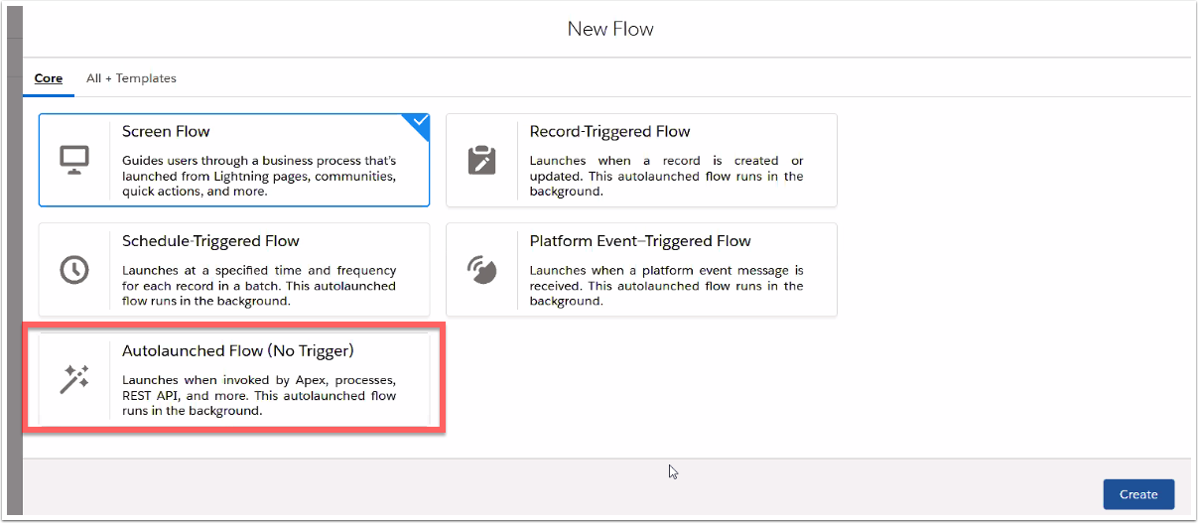

Autolaunched Flow

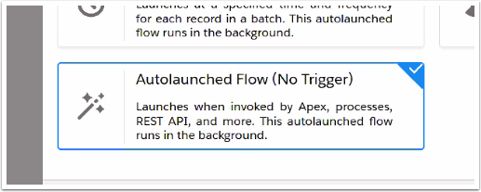

Start Page of the Autolaunched Flow

Click Manager

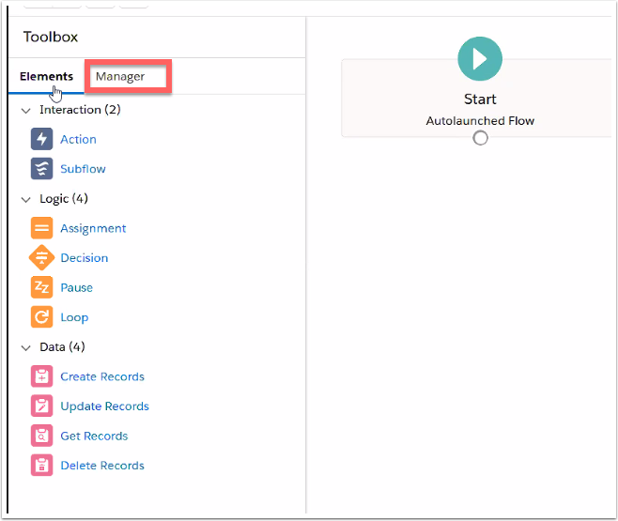

Click on New Resource

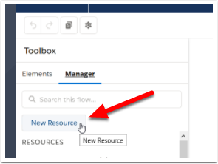

Create a Variable called Service

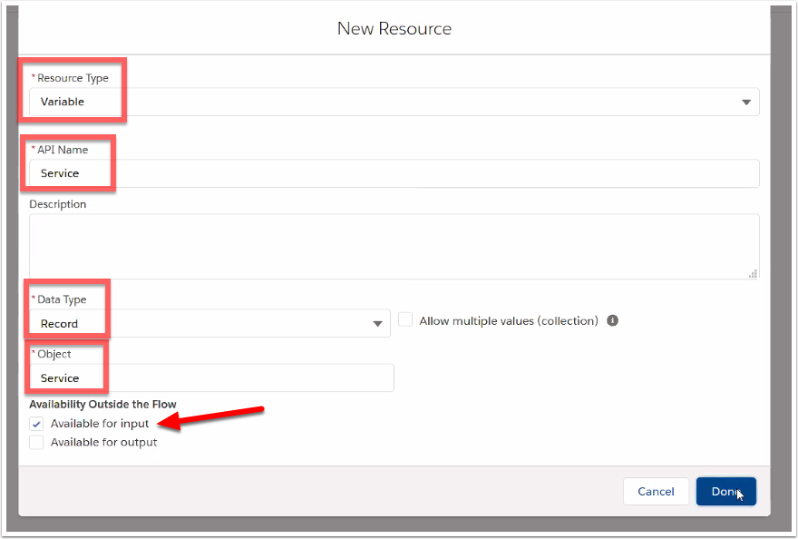

Create a Variable called Service Delivery

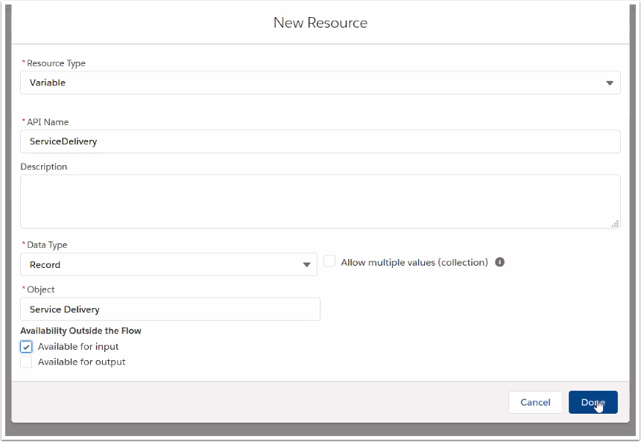

Create a Variable called VolunteerHours

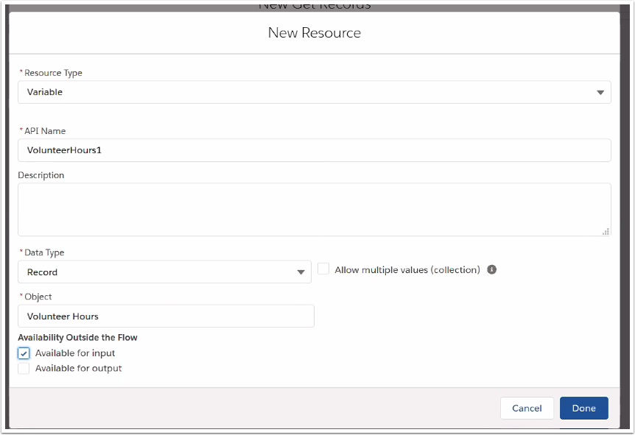

The variables show up in the Resources section of the Manager

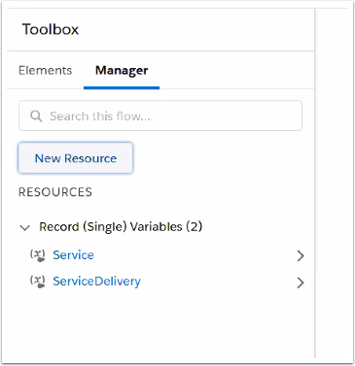

From Elements Tab, add a Get Records element under "Data"

From the Service Delivery Variable that we created, get Service Provider, and Delivery Date

We are checking to see if this matches with the Volunteer Hours fields equivalent to these PMM fields.

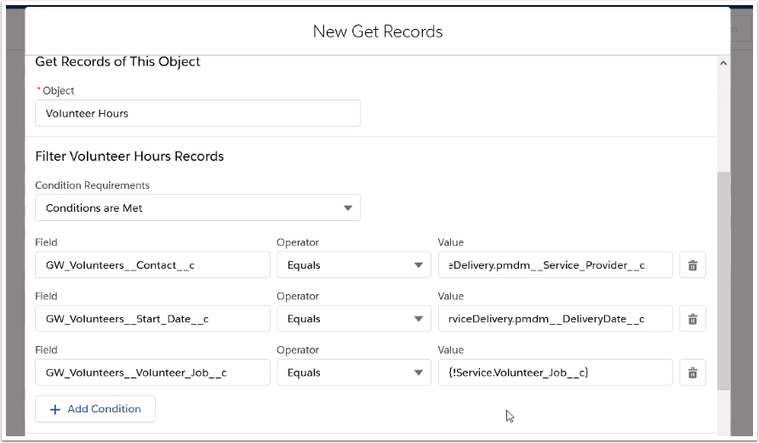

Specify where the results are being stored

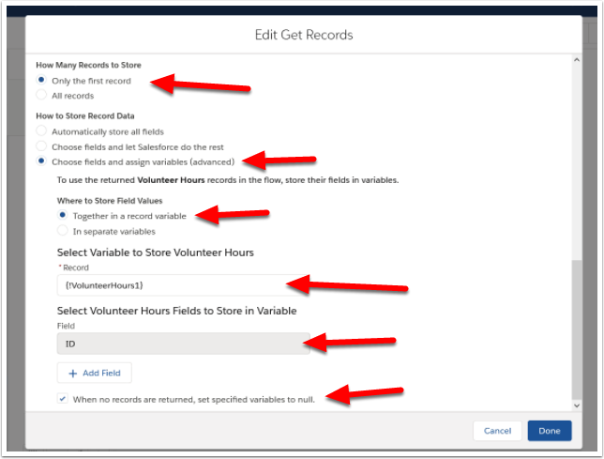

Connect start to Get Records

You do that by pulling on the little round dot.

The Decision is the Orange Signpost

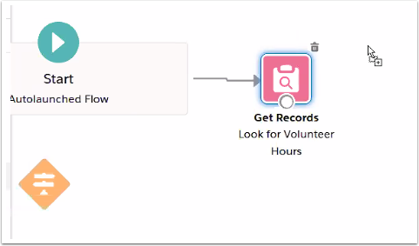

Create New Decision

Checks the variable we got from the Get Record to see if it is NULL

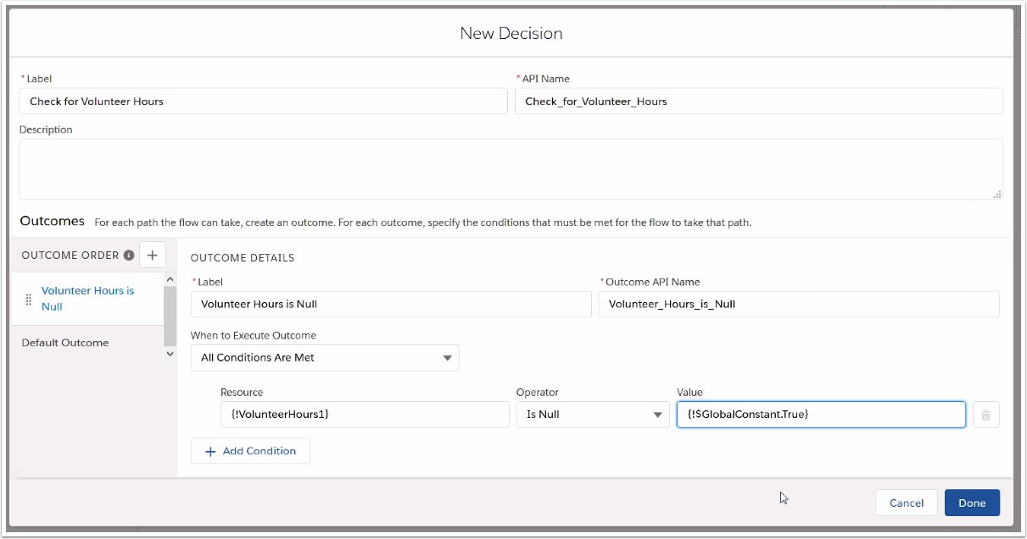

Create a Create Records element - Page 1

if there are no Volunteer Hours, we will create a new Volunteer Hours record.

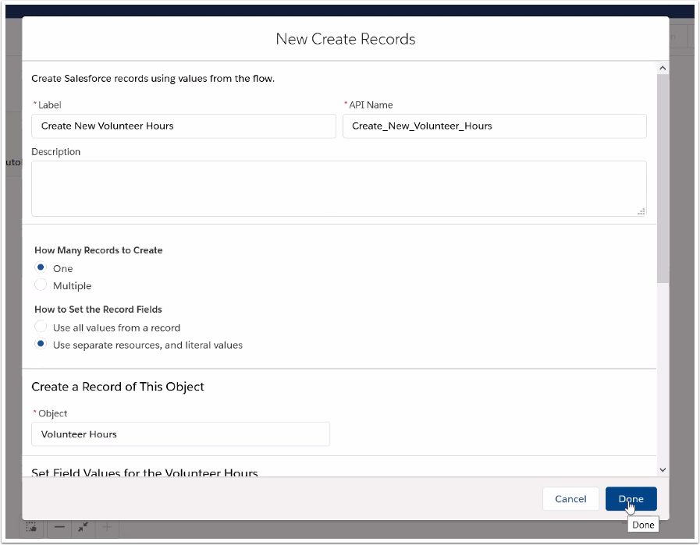

Create a Record - Specify values to include on the record - page 2

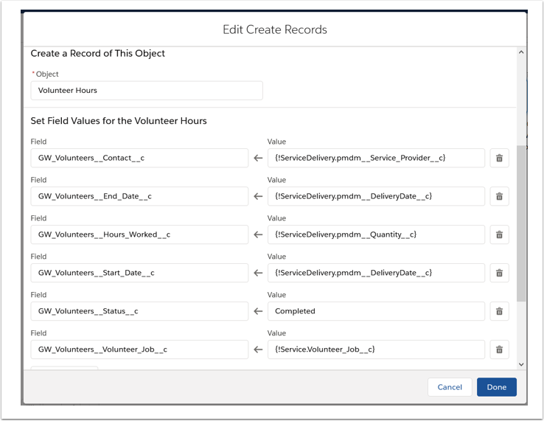

Create Record - Page 3

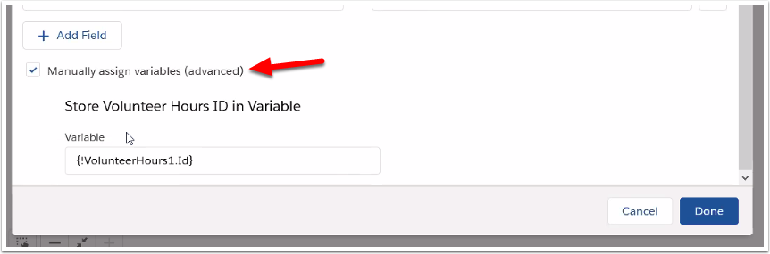

Here's how it looks on the flow: When Vol Hrs = NULL, create new vol hours

You will need to make that connection by pulling the line from the dot on decision to create records

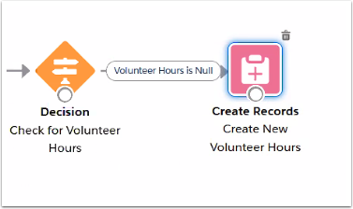

Create New Update Records - Page 1

Updating the Service Delivery with the Vol Hours information

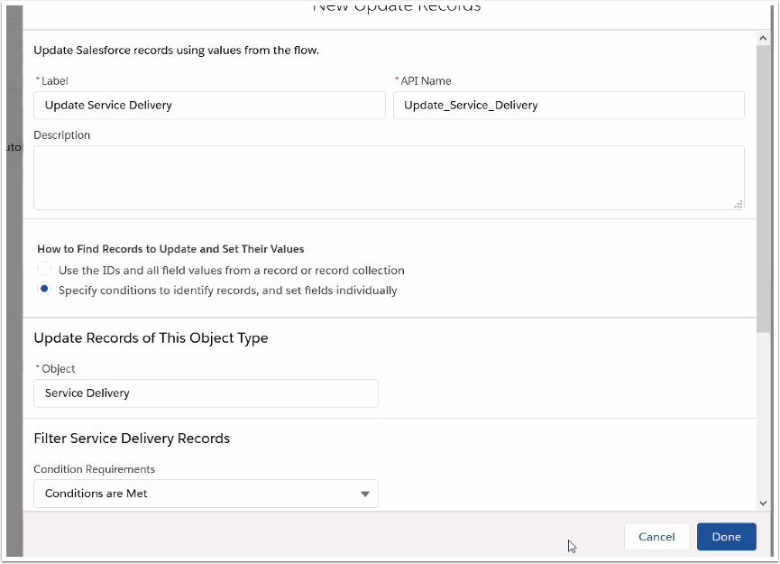

Create New Update Records - Page 2

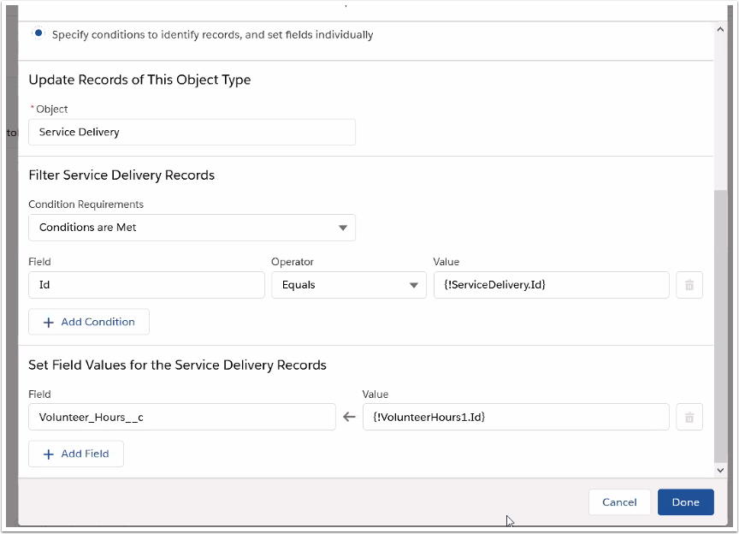

Make the connections...

From Decision to Update Records

From Create Records to Update Records

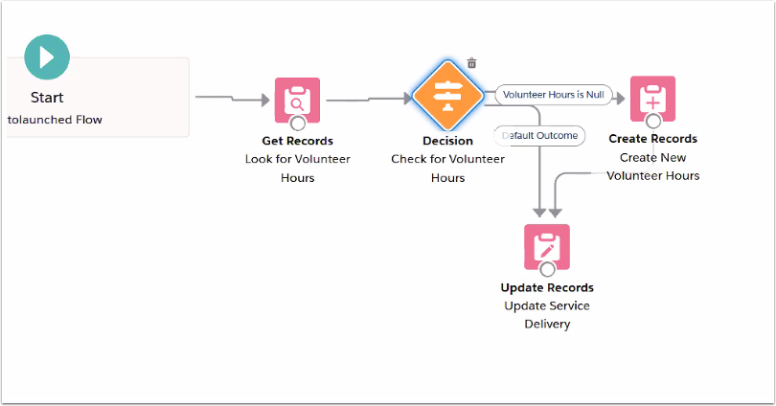

Create New Update Records element to update the Volunteer Hours record

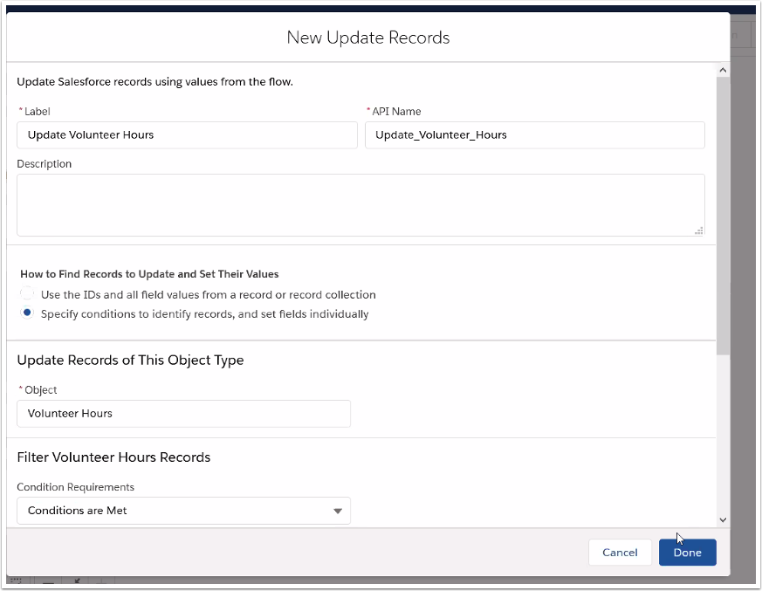

Update Records Page 2

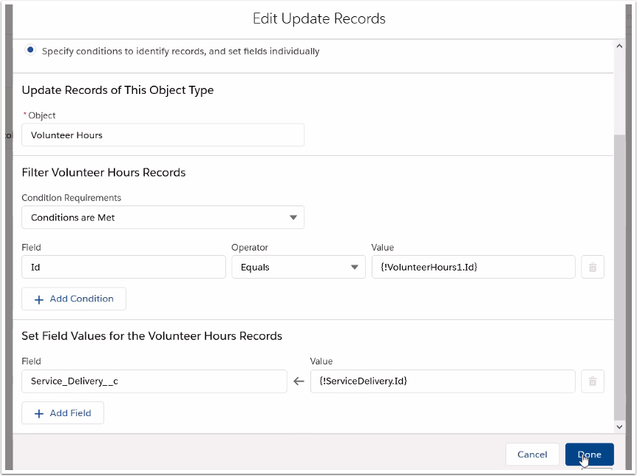

Connect Update Records (Service Delivery) to Update Records (Volunteer Hours)

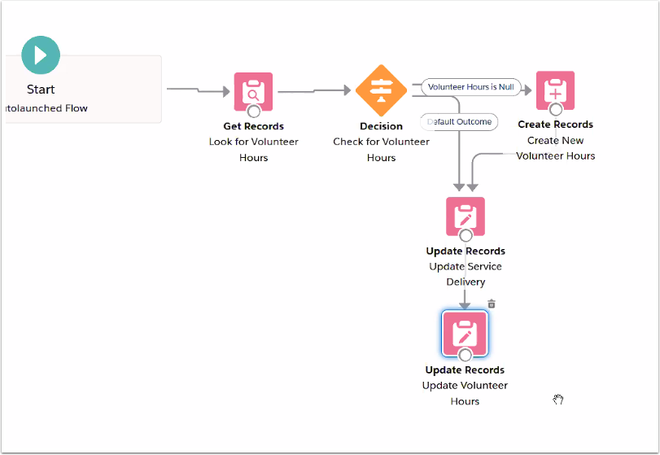

Save the flow

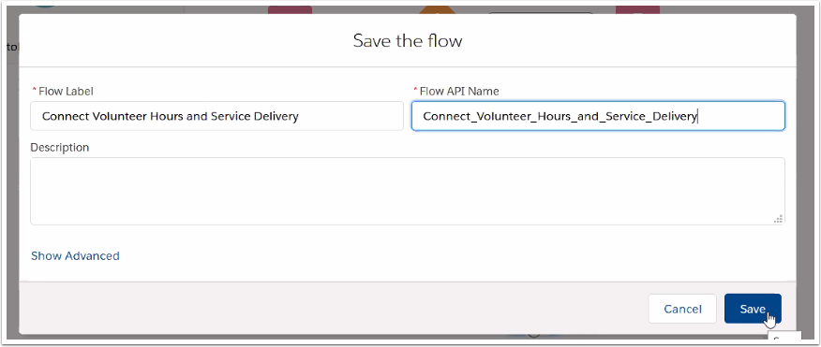

Activate the flow

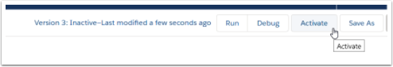

Go to Process Builder

Click New

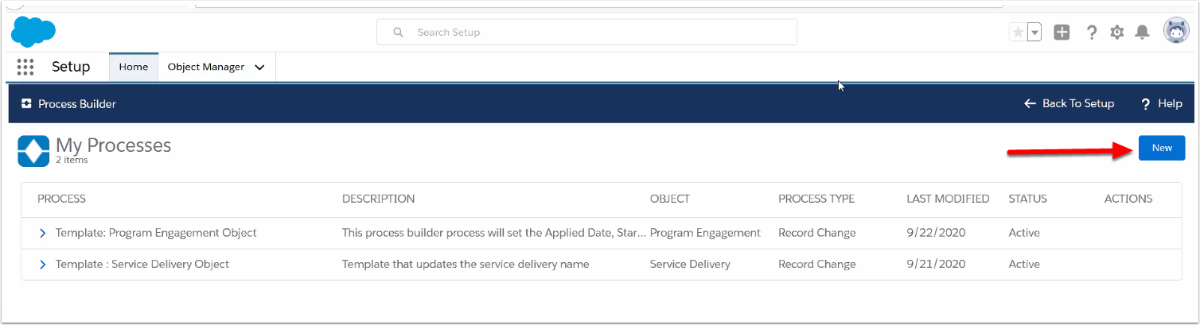

New Process

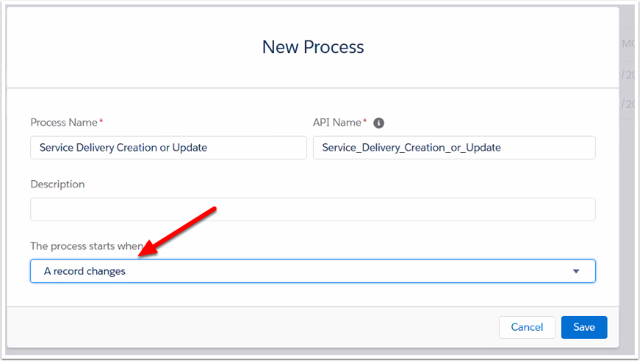

Object is Service Delivery

Disregard the warning message; you won't have active record change processes...Or if you do, it's still not a problem.

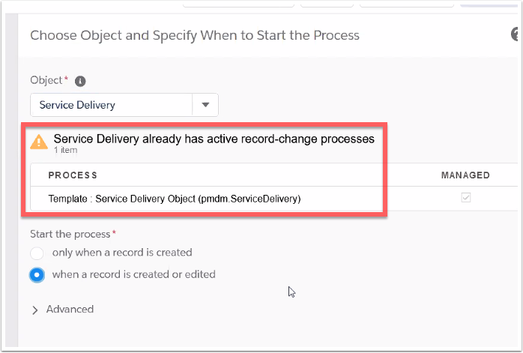

Service Delivery - criteria for launching the flow

Service on Service Delivery is not null

Volunteer job on Service (going through Service Delivery) not null

volunteer hours on Service Delivery is null

service providers is not null

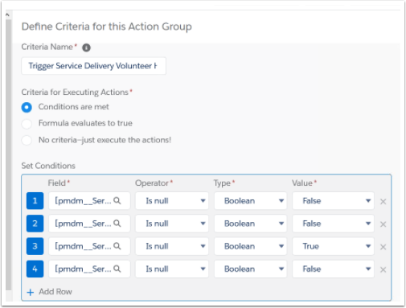

Example of going through Service Delivery to get to Volunteer Jobs on the Service Object

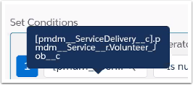

Now we set the Flow Variables in Immediate Actions

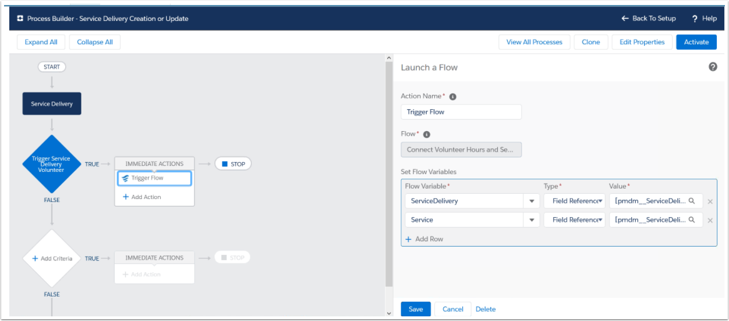

Select and Define Action

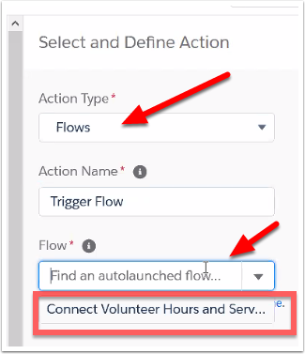

Click Add Row to list the connections between Flow and Process Builder

On the left, put the Service Deliverable variable and the Service Variable in.

The type will default to Field Reference

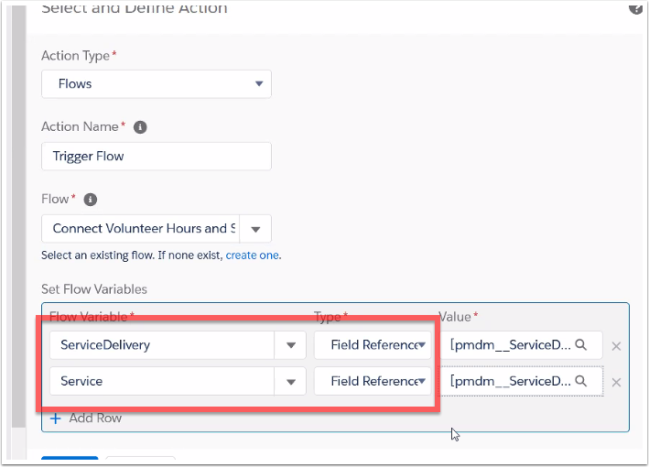

Click on the Value Box for Service Delivery

There will be a pop-up asking you if you want to use the pmdm__ServiceDelivery__c record that started your process. This is the record you want to use.

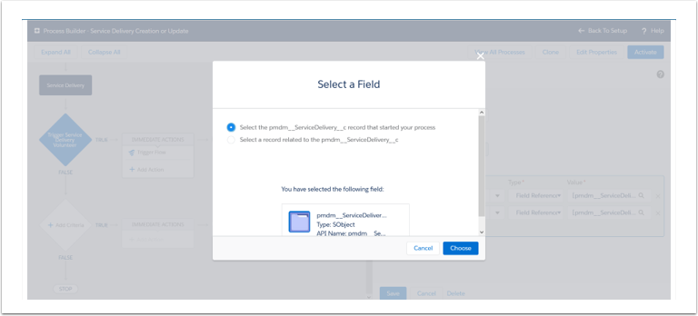

Click on the Value box for Service

There will be a pop-up starting from the Service Delivery ojbect and showing you all the field options. Search for Service (with the >) and select it.

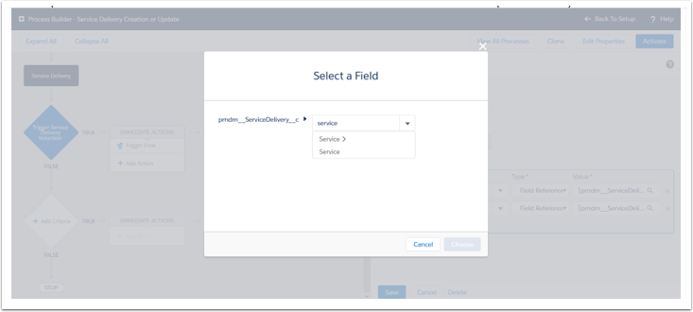

Save and Activate

Test the Results

Create Test Vol

Create test client

Create new campaign -

Create vol job

Create Service

Create Program

Service Deliveries...add new